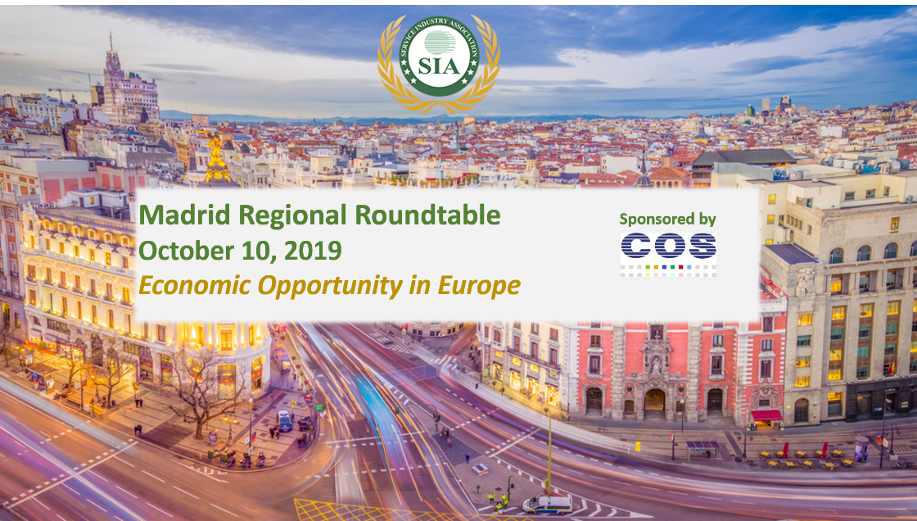
AGENDA

Thursday, October 10th
Location | Centro Cultural Adolfo Suárez – Ayuntamiento de Tres Cantos  Plaza del Ayuntamiento, 2, 28760, Tres Cantos, Madrid

8:30AM | Transportation from Hotel (Exe Plaza*) to Centro Cultural Adolfo Suarez - Ayuntamiento de Tres Cantos  * Paseo de la Castellana 191 Madrid 28046  Meet in front of the hotel
9:30AM – 10:00AM | Registration & Welcome Coffee in Centro Cultural Adolfo Suarez  Sponsored by
10:00AM – 10:15AM | City Mayor & COS Global President Speech  - Jesus Moreno, City Mayor of Tres Cantos  - Antonio de Pastors, Alliances Director and Business Development
10:15AM – 10:45AM | SIA Welcome Message  - Jerry Edinger, CFO
10:45AM – 11:45AM | Economic Impact Assessment report of ICT Secondary Market in Europe  - Jan Hoogstrate, Executive Director – Free ICT Europe Foundation
11:45AM – 12:15PM | Coffee Break & Networking  Sponsored by
12:15PM – 1:15PM | Service Trends, Vendor Strategies and How As-A-Service Works: What Support Providers Can Expect in the Next 1-3 Years  Rob Brothers, Program VP Datacenter & Support Services at IDC
1:15PM – 1:45PM | COS Global Presentation, Company Showcase  - Antonio de Pastors, Alliances Director and Business Development
1:45PM – 2:15PM | Kaspersky – COS Global Services Partner Presentation  - Jose Manuel Delgado, Strategic Business Development  - Damaso Ramos, Pre-Sales Director
2:15PM – 2:30PM | SIA Closing Remarks  - Jerry Edinger, CFO
2:30PM – 4:00PM | Lunch & Networking  Restaurant: “La Hípica de Tres Cantos”. Calle del Caballo, 4, 28760 Tres Cantos, Madrid  Sponsored by
4:00PM – 5:00PM | COS Global Services Premises Tour – COS Global Services Instalations  Av. de la Industria, 29, 28760 Tres Cantos, Madrid
5:00PM – 6:00PM | Networking: Wines & Cheese  Sponsored by
6:00PM – 6:40PM | Transportation to Hotel (Exe Plaza)
8:00 PM | Transportation from Exe Plaza to Puerta57  Meet in front of hotel
8:30 PM | Dinner  Puerta57  Estadio Santiago Bernabeu  Calle de Padre Damian  28036 MADRID  Cost of ~ 77€ / US$88 per person.  RSVP BY OCTOBER 3RD  Please inform Patricia Oponski patricia.oponski@servicenetwork.org whether you plan on attending.

