### C:\Users\Claudia\Documents\SIA LogoWeb 2 8 2013PNG\SIA_Logo_Web_Small.png

2016 Service Industry Global Executive Summit

for Service Leaders

*Growth & Profits through Partnerships & MegaTechTrends*

April 10-12 2016 Mirage Las Vegas

**31 th Annual Event Highlights**

* Association Address – SIA Board President, Tom York, CEO/President Essintial Enterprise Solutions
* **IDC Market Insights & Trends**
* Leadership 101
* Corporate Culture
* **Gartner TPM Trends**
* Big Data
* Trends Accelerating Growth
* Global Expansion
* Company Valuation
* Outsourcing
* The Digital Economy

Welcome Reception – Sunday, April 10, 2016

**Bermuda B Room (Registration Desk #2 opens at 5:00 pm)**

**6:30 pm Welcome and Speed Networking**

**Sponsored by**

 Strategic Day One: Monday, April 11, 2016

**Bermuda A: General Session; Bermuda B: Food & Exhibits**

**8:30-9:15 am Continental Breakfast – refreshments all day**

**Sponsored by**

****

**Breakfast with new members & SIA Board in Martinique A**

**9:15-9:30 am Welcome**

**Tom York, SIA Board President; Claudia Betzner, SIA Executive Director & Summit Chair**

**9:30-10:30 am MegaTechTrends of the Digital Economy**

**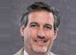**

**Rob Brothers, Vice President IDC Software**

**& Hardware Support Services**

* *Worldwide service delivery, software, and hardware trends*
* *Digital technologies impact on the enterprise and IT infrastructure*
* *Growth opportunities for service supply chain providers*

**10:30-11:00 am Break & Networking**

**11:00-12:00 pm Growth & Opportunities in the Digital Economy**

**Tomas O’Leary, President Origina and Session Chairman; Frank D’Alessio, President Maintech; Bill Comfort, President, DecisionOne Corporation; John Wozniak, President SMS**

* **Technology trends accelerating growth:** hyper scale, midrange, cloud, and distributed technologies

Strategic Day One: Monday, April 11, 2016

**Bermuda A: General Session; Bermuda B: Food & Exhibits**

**12:00-1:00 pm Lunch Sponsored by**



**1:00-2:00 pm Global Expansion: A Panel Discussion**

Bernd Appleby, President TERiX & Session Chairman (NA); Kow Ya, Executive Director DeClout (APAC); **Thomas Wolff, Director Partner Management, Technogroup (Europe); Joel Chait, Director Sales ISC Group (Central & Latin America)**

* + - * Is international growth and expanding your global footprint right for your company?
      * Cultural acceptance of TPMs in countries dominated by OEM service
      * Finding the right international partner – advantages/disadvantages of subcontracting & establishing foreign entities

**2:00-3:00 pm Valuing Your Company**

Michael Kosty, Vice President, Bregal Sagemount Capital; Tim McMahon, Managing Director and Grant Grava, Director,

Covington Associates

* What is your company worth?
  + - What are investment bankers and equity partners seeking?
    - Strategic partner vs. equity partner

**3:00-3:30pm Break & Networking**

**3:30-4:30 pm Breakouts (questions & sign-up on Summit app)**

* + - * + Big Data (Bermuda A) – Bernd Appleby, President TERIX and Big Data Committee Chair
        + Grow in the Cloud (Bermuda B) – Jeff Andrews, Chief Technology Officer GT Software
        + Cyber Security Issues Facing SMBs (B) – Dr. Richard Schroth, Managing Director Global Cyber Practice Newport Board Group

**6:00-7:30 pm Networking Cocktail Hour Sponsored by**

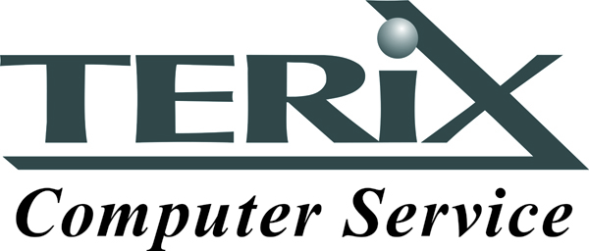

Operational Day Two: Tuesday, April 12, 2016

**Bermuda A General Session; Bermuda B: Exhibits Breakfast & Break**

**8:00-8:30 am Continental Breakfast Sponsored by**

****

**8:30-9:00 am State and Vision of the Association**

**Tom York, SIA Board President & President Essintial Enterprise Solutions**

**9:00-9:40 am TPM Trends and Opportunities**

**Christine Tenneson, Research Director, Gartner**

* What end users want
* Current and emerging competition
* Differentiating TPM offerings and value proposition for end users...and sourcing and procurement

**9:40-10:25am What keeps you up at night? A Panel Discussion**

**Dwight Strayer, C.O.O. Service Express & Session Chairman; Rich Guglielmo, C.O.O. Amcor Service Solutions; Greg Lorenzen, VP Sales & Marketing, Essintial Enterprise Solutions**

* Thinking outside the box
* Technology trends are depressing profits
* Re-engineering your labor force to today’s technology

**10:25-10:40 am Break & Networking**

**10:40-11:30 am Outsourcing: A Panel Discussion**

**Craig Youngblood, President LMS & Session Chairman;** Liz Benz, Executive V.P. Sales & Emerging Markets, Field Nation

* **When & how much outsourcing**
* **Outsourcing non-core**
* **Increasing profits by using partners**

Operational Day Two: Tuesday, April 12, 2016

**Bermuda A General Session; Bermuda B: Exhibits Breakfast & Break**

**11:30-12:30 pm Building a Performance Driven Culture that Drives Great Results**

Ron Alvesteffer, President & CEO, Service Express, Inc (SEI)

* How SEI’s unique Vision has led to shared success for employees, for SEI and for shareholders
* How tracking and using numbers the right way can improve employee engagement while ensuring they're focused on accomplishing the right things
* How SEI invests in people and creates an environment where they can work hard, have fun and get great results

**12:30-1:30 pm Lunch - Networking**

**Sponsored by**



**2:00 pm Breakouts**

* **Owners Rights – Free ICT, REPAIR.ORG, Tomas O’Leary, Todd Bone**
* **Networking – Network to partner or just to meet! Complete delegate listing and contact information provided to schedule in advance; The Board and Executive Director can help with introductions)**

Operational Day Two: Tuesday, April 12, 2016

**6:00 pm Cocktail Hour**

**Sponsored by**

**C:\Users\Claudia\Pictures\maintechlogo.png**

**7:00 pm Grand Finale Dinner LAVO Palazzo Tower**

**(Guest of attendee tickets available at Registration for $125 each)**

**Sponsored by**

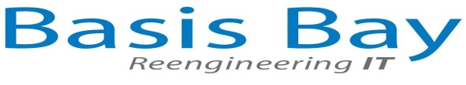 ****

**[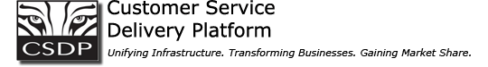](http://www.csdpcorp.com/)**

**9:30 pm After Party – 1OAK Mirage**