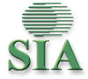
2164 Historic Decatur Road, Villa Nineteen, San Diego, CA 92106
619 221 9200 Fax 619 221 8201 www.servicenetwork.org

15 November 2010

Ms. Christine Varney
Assistant Attorney General
Antitrust Division
United States Department of Justice
950 Pennsylvania Avenue, NW
Washington, D.C. 20530

Dear Ms. Varney,

Please allow me to introduce the Service Industry Association (SIA), a 25 year old association of independent technology service providers. The association’s primary purpose is to help establish and sustain a truly open, competitive marketplace for the service and support of technically complex products. Open competitive marketplaces are deeply rooted in our national culture and consumers are accustomed to having choices. Our 130 plus members provide customers with service alternatives to the large equipment manufacturers such as Oracle (Sun), Hewlett-Packard, IBM, Cisco and the like. Many of our members compete directly with the large equipment manufacturers. Our membership provides hardware and software maintenance and repair offerings for computers, data storage and networking products, among others. Customers select independent service organizations (ISOs) for a variety of reasons, including greater flexibility of service offerings, customized service offerings, better service quality and lower cost, to name a few. Further information on SIA is available on our website: www.servicenetwork.org.

The relationship between the large equipment manufacturers and the ISOs has always been fiercely competitive as the manufacturers desired to retain hardware maintenance revenues and ISOs seek to entice customers away from the manufacturers. For the most part, the competition between the large manufacturers and the ISOs is conducted on a level playing field, with customers ultimately making the decision to either purchase hardware maintenance service from a large manufacturer, from an ISO or often splitting their purchasing decision between both.

After Oracle, Inc.’s acquisition of Sun Microsystems was finalized earlier this year, Oracle instituted a new set of policies in a clear attempt to monopolize the maintenance market for Sun hardware at the expense of ISOs. According to Oracle’s own responses to SIA, Oracle has instituted these new policies as a response to competitive pressures in the Sun hardware maintenance market. As officially described by Oracle in Oracle Hardware and Systems Support Policies, Effective date: 16-Mar-2010, (Attachment 1) and restated in Oracle Hardware and Systems Support Policies, Effective date: 24-September-2010 (Attachment 2) Oracle’s policies unfairly deprive ISOs of business and are the most onerous set of hardware maintenance policies in the entire Information Technology services market.

The potential business impact to ISOs is massive, as ISOs currently obtain approximately $2,371,000,000 of revenue from support of Sun products, according to SIA estimates and Sun Microsystems FY2009 financial reports. See Attachment 3, Sun Microsystems Service Revenue, FY2009. The loss of this business to Oracle’s anti-competitive policies will decimate ISOs and would negatively impact the hardware maintenance business in general.

With respect to hardware maintenance of contemporary Sun products, Oracle is unfairly competing with ISOs by not allowing customers to have a business relationship with ISOs if the customer also wants to preserve any relationship with Oracle whatsoever. This puts the customer in the predicament of either selecting an ISO for all their hardware maintenance needs and cutting all ties back to Oracle, (the manufacturer of the Sun hardware) or completely excluding the ISO from performing any service in order to preserve a relationship with the manufacturer of their hardware. The SIA contend this position by Oracle is an abuse of its dominant market position, access to its intellectual property and engineering and is deliberately targeted towards ISOs. Furthermore, for those customers who may elect to use an ISO initially but may return to Oracle support, Oracle has imposed onerous “return to Oracle” service restoration fees which only serve to intimidate customers from leaving Oracle support in the first place. The customer is intimidated to select either Oracle for all its Sun hardware maintenance needs or Oracle will deny any type of service to the customer if the customer selects an ISO. Oracle will not allow a customer to split its service requirements between Oracle and an ISO.

Specifically, if a customer selects an ISO for hardware maintenance of contemporary (other than end-of-service life) Sun hardware Oracle will
- Not support any of the customers Sun hardware (all or nothing)
- Not allow the customer to open a time and materials service call with Oracle
- Charge the customer requalification fees in order to bring the hardware back under Oracle support (Premium Support Qualification Service), and charge an additional reinstatement fee equal to 150% of the last-paid support fee, or 150% of the list technical support price for the covered hardware system, prorated from the date technical support is being ordered back to the date support lapsed.

In effect, the customer must choose to have all their contemporary Sun hardware maintenance provided by Oracle or Oracle will deny any maintenance service whatsoever, including time and materials service. To cut off all ties with the manufacturer of their hardware is a business risk unacceptable to most companies.

These are new policies thrust upon customers beginning 16 March 2010. Previously, customers who in good faith purchased Sun hardware from Sun and from Oracle before March 2010 enjoyed a choice of service options, including purchasing all the service from Oracle (Sun), a portion of their services from Oracle (Sun) and the balance from an ISO or purchasing all their services from an ISO and having the option of opening Time and Materials contracts with Oracle (Sun) for services not offered by the ISOs. Oracle is now pressuring customers to put all their Sun hardware under Oracle support or risk completely severing their maintenance relationship with Oracle.

The SIA initiated a dialogue with Oracle to address and discuss these policy changes on May 14, 2010. On June 29, 2010 Oracle responded to the SIA but did not address our concerns. This prompted another communiqué to Oracle on July 14, 2010 to actively discouraging fair and equitable competition. .Please refer to the attached, correspondence.

While SIA is very concerned with the new Oracle policies, SIA is equally concerned with the anti-competitive positions of other major manufacturers, particularly Hewlett-Packard and Cisco Systems. In September 2010,Hewlett-Packard removed access to software patches for their HP-UX UNIX operating system and Cisco Systems continues to bundle hardware and software support together. Taken together with Oracle’s recent changes to their maintenance policies, SIA believes the major manufacturers are actively discouraging fair and equitable competition.

SIA requests the Department of Justice compel Oracle to cease and desist exercising their anti-competitive policies which is primarily aimed at much smaller and vulnerable ISO organizations and keep the hardware maintenance market thriving and competitive and benefitting customers by allowing choice, flexibility and lower hardware costs of ownership.

Sincerely,

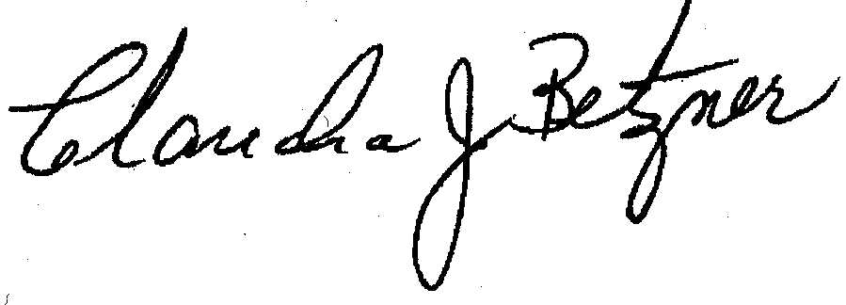

Claudia Betzner
Executive Director
Service Industry Association

Attachment 3
Sun Microsystems Service Revenue, FY 2009

The following is the SIA estimate of Sun hardware maintenance service revenues in jeopardy because of Oracle’s new anti-competitive policies.
The methodology used by SIA to calculate ISO’s portion of the Sun hardware maintenance market size takes into account three critical factors. The first factor is the percentage of the Sun hardware market shared between Sun and the ISOs. This number was historically between 45-55% the last several years.
The second factor is the actual Sun Services revenue from FY2009 as reported to the financial community. That amount is $3,648,000,000*. It stand to reason, therefore, if ISOs supported 50% of the market and if ISO’s sold maintenance services at the same price as Sun (actually, ISOs sell at a discount to the Sun prices), the dollar amount of the ISO market would be identical to Sun’s dollar amount, or $3,648,000,000.
The final factor is the discount that ISOs sell comparable hardware maintenance services. That discount percentage is approximately 35%, but can vary significantly based upon the age of the hardware (ISOs can support older hardware at an even greater discount). After applying the 35% discount, the size of the Sun hardware market supported by ISOs is $2,371,000,000.

Sun FY2009 Services Revenue* $3,648,000,000
ISO percent of market, average 50%
ISO value of market, (before discount) $3,648,000,000
ISO price advantage over Sun (discount) 35%
ISO net market size $2,371,000,000

Attachment 6, Oracle Response to SIA, June 29, 2010, paragraphs 3 and 5.
Attachment 2, Oracle Hardware and Systems Support Policy, Sept 24, 2010, page 2 paragraph 3.
Attachment 2, Oracle Hardware and Systems Support Policy, Sept 24, 2010, page 3 paragraph 3.
Attachment 2, Oracle Hardware and Systems Support Policy, Sept 24, 2010, page 2 paragraph 4 and 5.
Attachment 5, SIA Letter to Oracle, May 14, 2010
Attachment 6, Oracle Response to SIA, June 29, 2010
Attachment 7, SIA Response to Oracle, July 16, 2010

